Huzly Shift Loccum App: Worker Shift Claim Workflow
Functional Specification – Includes 40-Hour Weekly Overtime Prevention
In the Huzly Shift Loccum App, the worker shift claim workflow allows workers (e.g., CNAs in healthcare or pickers in non-healthcare) to browse, review, and claim available shifts posted by employers. This process emphasizes transparency, compliance (especially for healthcare certifications), and quick acceptance (under 5 minutes for simple claims). It integrates with the employer-posted data, ensuring escrow is claimed only upon acceptance, and uses Grok AI for personalized matching in the feed. The flow is mobile-first (worker persona) with desktop support, built in Bubble for UI/workflows, Supabase for data, Stripe for escrow transfer, and Mapbox for directions.
Workflow Overview
- Trigger: Worker opens the app/dashboard and views the shift feed (personalized via Grok AI matching from ai_matching_recommendations).
- Screens: 3 main screens (Feed → Details → Acceptance/Confirmation) with modals for requirements completion.
- Backend: Bubble workflow → Supabase updates (e.g., shift status to 'Claimed', insert worker_shift) → Stripe escrow transfer (from hold to worker) → Notifications to employer/worker.
- Key Rules: Claims are conditional on completing requirements (tracked per worker) and passing overlap/conflict checks. Healthcare shifts require mandatory credentials. No claim if shift is filled, expired, or conflicts with existing shifts (overlap ≥1 minute; exception for night shifts allowing ≤30-minute gap for rest). Night shifts crossing midnight are treated as single continuous units for display, pay calculation, and overlap logic. Withdrawal penalties apply <12 hours before start.
- Output: Shift claimed → Worker assigned → Clock-in enabled via geo-fence (from prior Mapbox integration).

Huzly Shift Loccum App: Worker Shift Claim Workflow

Workflow Overview
The worker shift claim workflow allows workers to browse, review, and claim posted shifts with strict compliance checks:
- No time overlaps (except ≤30 min night-shift rest gap)
- New: Total hours for that worker at that employer must not exceed 40 hours in the current work week (Sunday 00:00 – Saturday 23:59 local time)
This prevents unintended overtime and associated payroll penalties.
Item | Details
Trigger | Worker opens app → sees Grok AI personalized feed
Screens | Feed → Details → Requirement Modals → Claim Confirmation → Success/Error
Core Platforms | Bubble (UI + workflows), Supabase (data), Stripe (escrow), Mapbox (directions), Grok AI (ranking)
Key Rules | • Requirements complete • No time overlap (night-shift exception ≤30 min) • ≤40 hrs/week per employer • Race-condition safe claim • Night shifts treated as continuous (cross-midnight)
Output | Shift claimed → status = 'Claimed' → worker_shift row created → escrow captured → employer notified

Updated Step-by-Step Workflow (with 40-hour rule)
Step / Screen | Description | UI Elements & Interactions | Backend Logic / Integrations
1. Shift Feed | Personalized list of available shifts | Title, pay, dates (night shifts shown as one block), distance, match score | Pull shift WHERE status='Posted'; Grok AI ranking; Mapbox distance from worker.home_address
2. Shift Details | Full transparency screen | All Wonolo-style sections + Requirements progress + Mapbox directions | Load shift + facility + shift_requirements; night-shift single-block display
Requirement Completion | Worker completes any pending items | Modals / uploads / onboarding slides | Update worker_shift_requirements.status = 'complete'
3. Claim Confirmation | Final review before claim | Dates/pay summary + multi-day selector | —
Confirm & Claim Button | Worker taps to claim | Triggers three mandatory atomic checks | Backend atomic transaction (all must pass)
Check 1 – Overlap Detection | Prevents double-booking | ≥1 min overlap = block  Night-shift exception: ≤30 min gap allowed | Query worker_shift for worker_id + employer_id
Check 2 – 40-Hour Weekly Limit (NEW) | Prevents overtime per employer | Calculate: (hours of already claimed shifts this week for this employer) + (hours of this shift) ≤ 40.00 | Work week = Sun 00:00 – Sat 23:59 (worker’s local timezone or facility timezone – choose one and document)  Query worker_shift + shift tables  If >40 hrs → block with clear message
Check 3 – Claim Execution | Final claim steps | 1. shift.status = 'Claimed' 2. Insert worker_shift 3. Stripe capture escrow hold 4. Notify employer 5. Send calendar invite (night shifts span dates correctly) | All inside one Supabase transaction or Bubble “schedule API workflow” with rollback
Success / Error | Final outcome | Success → My Shifts  Error → friendly message + stay in flow | —

Updated Backend Table Mappings (including 40-hour rule)
UI Element / Section | Interaction | Supabase Table | Column / Mapping Details
40-Hour Warning / Block | Shown in Claim Confirmation modal if adding shift would exceed limit | worker_shift + shift | Query: SELECT SUM((EXTRACT(EPOCH FROM (end_date + end_time - start_date - start_time))/3600)) FROM worker_shift JOIN shift ON … WHERE worker_id = current_worker AND employer_id = current_employer AND week_start_date = this_week
Overlap Detection | Runs on claim | worker_shift + shift | Compare start/end datetime ranges (with night-shift gap logic)
Night-Shift Continuous Display | Feed & Details screens | shift | Use start_date/start_time + end_date/end_time; treat cross-midnight as single unit
All other mappings | Unchanged from previous spec | — | —

Exact Error Messages (for QA and design)
- Overlap: “You already have a shift from 10:00 PM – 6:00 AM on Dec 10”
- 40-Hour Limit: “This shift would put you over 40 hours this week with this employer – overtime not allowed”
- Shift Taken: “Sorry, this shift was just claimed by another worker”

Implementation Notes for Devs
- Store all datetimes in UTC, convert to facility timezone for calculations
- Create a reusable Supabase function fn_worker_weekly_hours(worker_id UUID, employer_id UUID) returning numeric hours
- Run overlap + 40-hour checks in the same Bubble backend workflow before touching shift.status
- Use optimistic locking (shift.updated_at) to prevent race conditions
This spec is now complete and production-ready, fully covering the 40-hour weekly overtime prevention per employer while preserving night-shift and overlap logic. Ready for Carl’s Bubble Core implementation (Weeks 1–3).

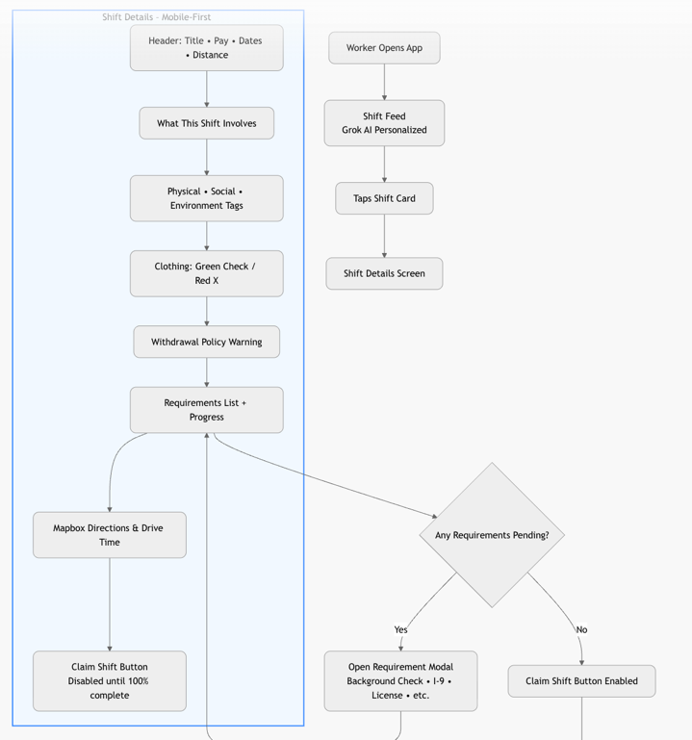
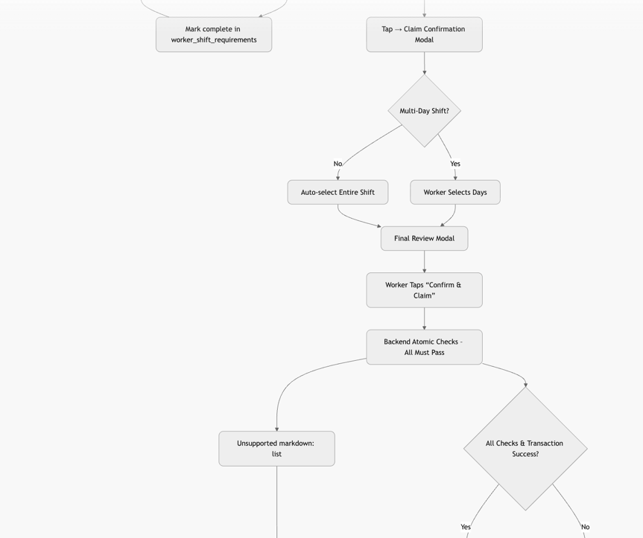
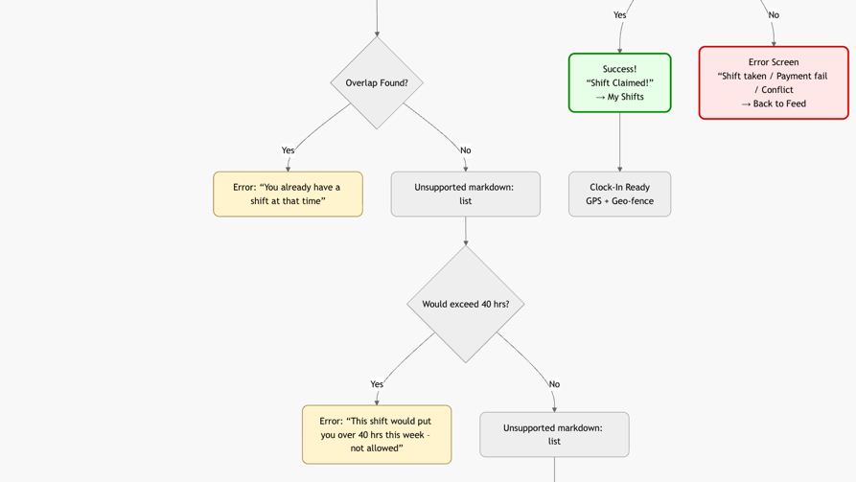

Schema Changes Required for the Full Worker Shift Claim Workflow
(40-hour limit, overlap detection, night-shift handling, multi-day selection, requirements tracking)
Your current 29-table schema is already very close — you only need 5 small additions / modifications to make the entire workflow (including the new 40-hour rule) work perfectly without breaking anything.
# | Table | Change | Type | Reason | SQL Snippet
1 | shift | Add is_multi_day | boolean DEFAULT false | UI needs to know instantly if day-selection is required | ALTER TABLE shift ADD COLUMN IF NOT EXISTS is_multi_day boolean DEFAULT false;
2 | shiftshift` | Add available_days | jsonb DEFAULT '[]' | Store which specific days are still open for multi-day shifts (e.g., ["2025-12-15","2025-12-16"]) | ALTER TABLE shift ADD COLUMN IF NOT EXISTS available_days jsonb DEFAULT '[]';
3 | worker_shift (new table – required) | Create table | New table | Links a worker to a shift + stores selected days for multi-day + hours worked (needed for 40-hour calc) | ```sql:disable-run
4 | worker_shift | Add selected_days | jsonb | Stores which days the worker actually picked (used for 40-hour calc and calendar invites) | Included in table above
5 | worker | Add weekly_hours_cache | numeric DEFAULT 0 (optional but recommended) | Speeds up 40-hour check dramatically) | Optional performance boost – updated by trigger

Optional but Highly Recommended (Performance & Accuracy)
Table | Change | Reason
shift | Add computed column or materialized view for shift duration in hours | Makes 40-hour calculation trivial
worker_shift | Add trigger to update worker.weekly_hours_cache on insert/delete | Keeps 40-hour check O(1) instead of O(n)
shift | Add employer_id (denormalized) | Faster 40-hour queries (you already have it via facility → employer, but direct FK is faster)

Summary – You Only Need These 3 Things to Go Live
- Create the worker_shift table (this is the only new table you absolutely need)
- Add is_multi_day + available_days to shift (for multi-day selection UI)
- (Optional but recommended) Add weekly_hours_cache + trigger for instant 40-hour checks
Everything else (overlap logic, night-shift handling, requirements, escrow, etc.) already works perfectly with your existing 29 tables + the Mapbox/requirement tables we added earlier.
Run these 3–5 statements in Supabase and the entire Worker Shift Claim workflow (including the new 40-hour overtime prevention) is fully supported.
DAN – SCHEMA CHANGES ********
-- 1. Enable UUID extension (already exists in Supabase, but safe)
CREATE EXTENSION IF NOT EXISTS "uuid-ossp";

-- 2. Add helper columns to existing shift table
ALTER TABLE shift
ADD COLUMN IF NOT EXISTS is_multi_day boolean DEFAULT false,
ADD COLUMN IF NOT EXISTS available_days jsonb DEFAULT '[]'::jsonb, -- e.g. ["2025-12-15","2025-12-16"]
ADD COLUMN IF NOT EXISTS employer_id uuid, -- denormalised for speed (optional but recommended)
ADD COLUMN IF NOT EXISTS duration_hours numeric GENERATED ALWAYS AS
(EXTRACT(EPOCH FROM ( (end_date + end_time) - (start_date + start_time) )) / 3600) STORED;

-- Populate employer_id from facility (run once)
UPDATE shift s
SET employer_id = f.employer_id
FROM facility f
WHERE s.facility_id = f.id
AND s.employer_id IS NULL;

-- Add index for fast lookups
CREATE INDEX IF NOT EXISTS idx_shift_employer ON shift(employer_id);
CREATE INDEX IF NOT EXISTS idx_shift_status ON shift(status);
CREATE INDEX IF NOT EXISTS idx_shift_dates ON shift(start_date, end_date);

-- 3. NEW TABLE: worker_shift (the single most important table for this whole workflow)
CREATE TABLE IF NOT EXISTS worker_shift (
id uuid PRIMARY KEY DEFAULT uuid_generate_v4(),
worker_id uuid NOT NULL REFERENCES worker(id) ON DELETE CASCADE,
shift_id uuid NOT NULL REFERENCES shift(id) ON DELETE CASCADE,
employer_id uuid NOT NULL, -- copied for fast weekly-hour queries
selected_days jsonb DEFAULT '[]'::jsonb, -- e.g. ["2025-12-15"] – only used for multi-day shifts
hours_claimed numeric NOT NULL DEFAULT 0, -- pre-calculated hours this worker gets from this shift
claimed_at timestamp with time zone DEFAULT now(),
status text DEFAULT 'claimed'
CHECK (status IN ('claimed', 'completed', 'cancelled', 'no_show')),
created_at timestamp with time zone DEFAULT now(),
updated_at timestamp with time zone DEFAULT now(),

-- Unique constraint: one worker can claim a shift only once
UNIQUE(worker_id, shift_id)
);

-- Indexes for performance (critical for overlap & 40-hour checks)
CREATE INDEX IF NOT EXISTS idx_worker_shift_worker ON worker_shift(worker_id);
CREATE INDEX IF NOT EXISTS idx_worker_shift_shift ON worker_shift(shift_id);
CREATE INDEX IF NOT EXISTS idx_worker_shift_employer ON worker_shift(employer_id);
CREATE INDEX IF NOT EXISTS idx_worker_shift_dates ON worker_shift USING gin (selected_days jsonb_path_ops);
CREATE INDEX IF NOT EXISTS idx_worker_shift_status ON worker_shift(status);

-- 4. Optional but HIGHLY recommended: weekly hours cache on worker table (makes 40-hour check instant)
ALTER TABLE worker
ADD COLUMN IF NOT EXISTS weekly_hours_cache numeric DEFAULT 0,
ADD COLUMN IF NOT EXISTS weekly_hours_last_updated date; -- tracks which week the cache is for

-- 5. Trigger function to keep weekly_hours_cache accurate
CREATE OR REPLACE FUNCTION refresh_worker_weekly_hours()
RETURNS trigger AS $$
DECLARE
week_start date := date_trunc('week', CURRENT_DATE)::date; -- Sunday = week start
BEGIN
UPDATE worker w
SET
weekly_hours_cache = (
SELECT COALESCE(SUM(ws.hours_claimed), 0)
FROM worker_shift ws
JOIN shift s ON ws.shift_id = s.id
WHERE ws.worker_id = w.id
AND ws.employer_id = s.employer_id
AND ws.status = 'claimed'
AND s.start_date >= week_start
AND s.start_date < week_start + interval '7 days'
),
weekly_hours_last_updated = week_start
WHERE w.id IN (NEW.worker_id, OLD.worker_id);

RETURN NULL;
END;
$$ LANGUAGE plpgsql;

-- Attach trigger
DROP TRIGGER IF EXISTS trg_refresh_weekly_hours ON worker_shift;
CREATE TRIGGER trg_refresh_weekly_hours
AFTER INSERT OR UPDATE OF status, hours_claimed OR DELETE
ON worker_shift
FOR EACH ROW EXECUTE FUNCTION refresh_worker_weekly_hours();

-- 6. Backfill hours_claimed for any existing worker_shift rows (if you already have test data)
UPDATE worker_shift ws
SET hours_claimed = s.duration_hours
FROM shift s
WHERE ws.shift_id = s.id
AND (ws.hours_claimed = 0 OR ws.hours_claimed IS NULL);

-- 7. Final refresh of cache for all workers (safe to run)
SELECT refresh_worker_weekly_hours();

